



Android project proposal

On

**Zippy – A ride sharing application**



Submitted by: Rupesh Dhakal

Batch: Sep 2019 Section (C)

Module Leader: Kiran Rana

Table of Contents

1. Introduction 3

a) Project Introduction 3

b) Justification of the project 3

I. Background of the project 3

II. Problem statement 3

c) Description of the project 4

I. Features of the project 4

2. Aims and Objective of the project 5

3. Development methodology 6

a) Description of the methodology 6

b) Design pattern 7

4. Configuration Management 8

5. Prototyping 9

a) prototyping 9

6. Conclusion 12

7. References 13

**Table of figure**

Figure 1 Phases of waterfall model 6

Figure 2 MVC Architecture 7

Figure 3 GitHub link 8

Figure 4 Login and registration 9

Figure 5 pickup and destination setting 10

Figure 6 Confirm Booking page Prototype 11

# Introduction

Transportation is important for everyone in this world. When traveling toward daily commute people’s biggest concern is to find comfy safe transportation facilities. As the population density of cities here in Nepal is increasing day by day its important to provide transportation service to the people more effectively. To make transportation smart and easy I will be developing my application called **Zippy-A ride sharing application**

## Project Introduction

Zippy is a ridesharing application which allows people to travel to their destination fast. By using this application people do not need to wait for public transportation in hurry. In this application people can request ride just by selecting the pickup location and destination and the nearby taxi or a vehicle that is registered to this application service will be at the service. By implementing this application to the practical world, it might improve the current hustle and bustle that is going on with public transportation.

## Justification of the project

### Background of the project

Tension, frustration evolves in human if they have to search for a vehicle to go to their destination, as the current transportation system is worse where people have to stand and stay in traffic for long time. People tends to ignore these things which leads towards different casualties like pickpocketing, not reaching to the destination in time. People are unaware of the location if they have to travel to new location until now. This is the reason behind developing an application that provide the facility for people to request a ride in the location they desire just in couple of clicks. You can access the application anytime, anywhere.

**Tools that I will use are**: Android Studio, Figma (Designing tool) etc. I have produced expected amount of work by understanding the requirement and managing the time to complete the work (I have used Gantt chart for managing time).

### Problem statement

Problem statement determines the problem that the project can solve after the project is ready. This project can minimize the old ways of searching and waiting for vehicle. Way of waiting long time and also being uncomfortable while traveling is very frustrating. In my notion this project will definitely overcome those problem.

My main moto to develop this application is that user can benefit in various ways by using this application like saving time and enjoying cheap and comfortable rides. Spending relatively less time compared to the old ways if we can get better result then it’s better to adapt the new trends.

## Description of the project

### Features of the project

Since the functionalities of the admin is web based it will not be integrated to the android application directly instead if the data is needed then it will be extracted via API which will be created in web.

Features of the application are listed below

* **Authentication**

Authentication feature includes signup and login feature. Only authenticated user can access the application.

* **Normal User**

When users are logged in as passenger, they will be able to use these features:

* + Search location
  + Set pickup and destination location
  + Confirm the ride
  + Cancel the ride booking
  + View history and current activity
  + View and Edit profile
  + Notification (about ride conformation)

If the booking of the rides won’t get accepted in the period of 2 min user will receive some kind of message like service not available.

* **Rider**

When user is logged in as rider, they will be able to access these functionalities:

* Viewing the booking request of the customer
* Accepting or canceling the request
* View and edit their profile
* Can view client phone number if accepted
* View current booking location request.
* Enter 4-digit code after accepting the ride (after accepting the ride information regarding the ride and its cost will be send to admin).

# Aims and Objective of the project

**Aims:** aim is something that is going to achieve. Aims that this project can achieve are listed below:

* Make available of the facilities of selecting the pickup and destination place.
* Make user able to book for the rider that will be dropping off them to the selected location.
* Making application user friendly and attractive.
* Making application run smoothly alongside making performing the functionality of the application without any errors.

**Objective:** objective determines the action that will be performed to fulfil the aim

* User will have facility to login which will allow user to use different facilities that will be developed in this application.
* To make application user friendly and attractive I have performed prototyping about how the final project will look after it is developed and to make it more attractive suitable color alongside with good looking typography was implemented.
* To make application run smoothly and make it free from error I will be performing different testing method like: unit testing, black box testing, unit testing etc.

# Development methodology

## Description of the methodology

I have used **waterfall** methodology to develop the application. Waterfall is the sequential process of developing application i.e. step by step process so by implementing this methodology I can track my progress pretty smoothly. Other reasons for choosing waterfall methodology are:

* Waterfall model is simple and easy to understand (Sharma, 2019)
* Since my project is small and requirements are well understood so using this model will be suitable.
* 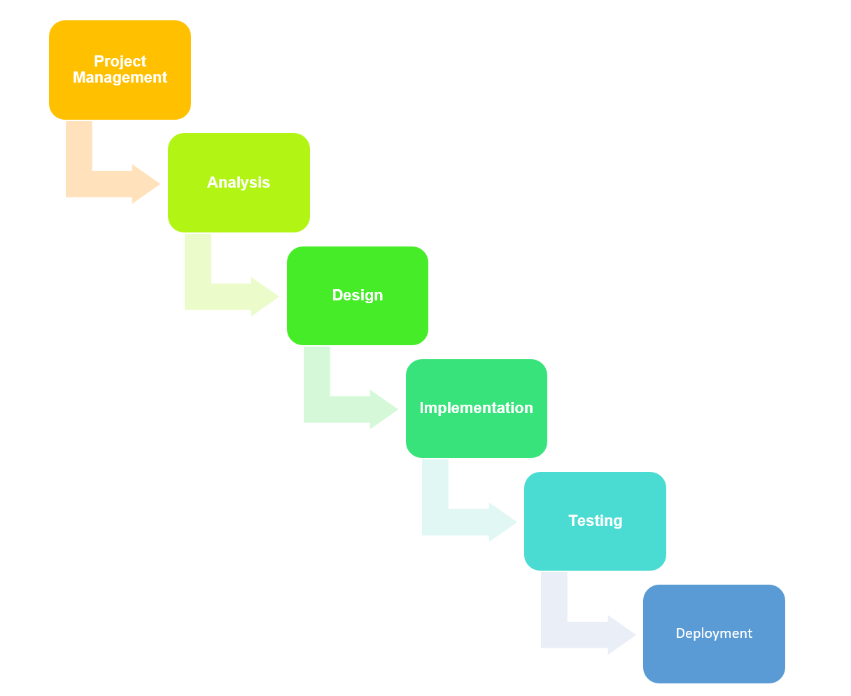Project will be easy to manage because the model is rigid itself.

Figure 1 Phases of waterfall model

## Design pattern

I have used MVC design pattern. Here M - Model, V - View and C – Controller. The reasons for using MVC pattern are: (Solution, 2019)

* Since **Model deals with the logical implementation, View deals with the interface (UI) and controller handles user interaction** MVC helps to categorize the responsibility of each fields.
* Modification: If we are requiring to make any sort of modification in the code then it will be easier as code are well managed. If modification is done in one class then it will not affect other classes since functionality are divided into individual classes.
* High Cohesion and Low coupling

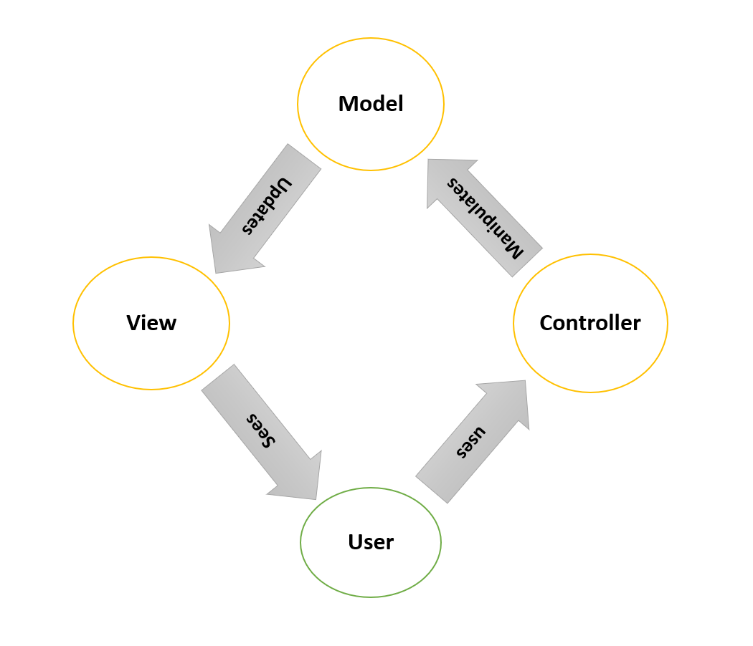

Figure 2 MVC Architecture

# Configuration Management

Configuration Management is the process of establishing and maintaining consistency of the product’s performance, functional and physical attributes with its requirements, design and operation information through its life (Rouse, 2019) . In Information Technology it is also called **Software Configuration Management (SCM). SCM** process is looked up by the active person searching for the best solution to handle changes in software projects. Git hub is also one of the ways to manage the modified code where all of the changes are updated regularly.

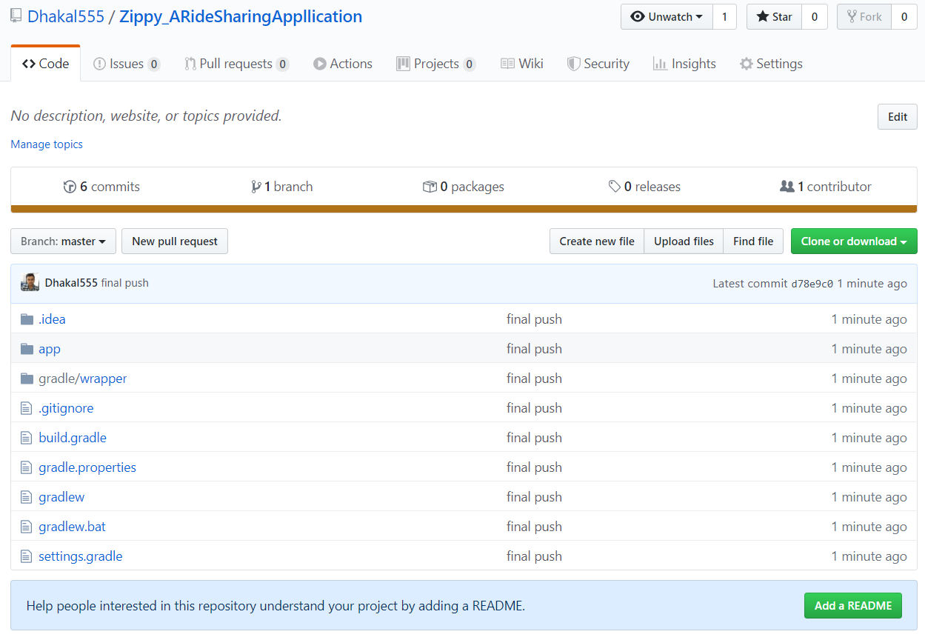

Figure 3 GitHub link

# Prototyping

Prototyping is an early sample of any final UI. Before developing the final user interface it’s important to create prototype because it let us to identify how the final product is going to look. Error that might occur during the development might get eliminated by making prototype at the first place.

## prototyping

Prototype that I have created for my application are:

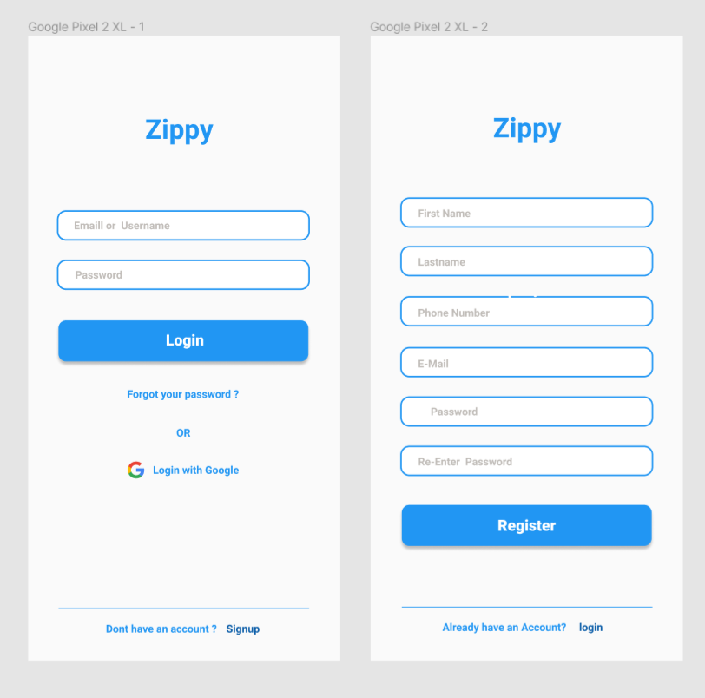

Figure 4 Login and registration

**Setting up pickup and destination location**

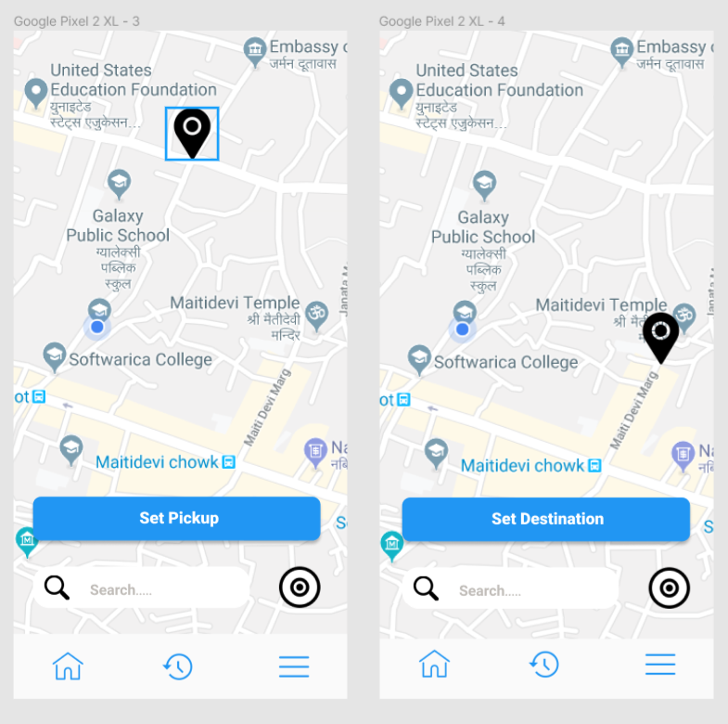

Figure 5 pickup and destination setting

**Confirm Booking page Prototype**

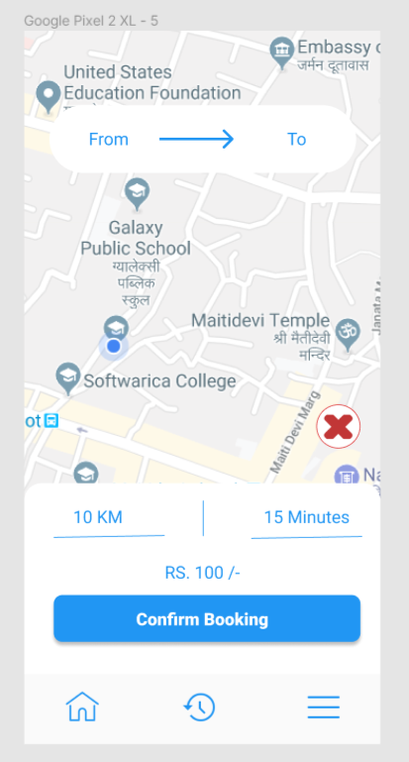

Figure 6 Confirm Booking page Prototype

# Conclusion

At conclusion I have successfully mention how my project will function by giving introduction of the project. Background of the project is given to know why the project was going to be built in the first place. I have also mention what problem can be solved by developing this project. Development methodology of the project is also provided alongside the methodology used to develop and design pattern that I will be using. Configuration management and prototyping was also done.

# References

Rouse, M. (2019, 1 5). *Tech Target*. Retrieved from Tech Target: https://searchitoperations.techtarget.com/definition/configuration-management-CM

Sharma, L. (2019, 11 26). *tools*. Retrieved from tools: https://www.toolsqa.com/software-testing/waterfall-model/

Solution, S. (2019, 1 3). *Medium corporation*. Retrieved from https://medium.com/@socraticsol/why-mvc-architecture-e833e28e0c76